IELTS
Vocabulary

About this document
Vocabulary is a very important part of the IELTS exam. It’s also important to understand that each section of IELTS requires different vocabulary. In this document, we will list vocabulary words for the Listening, Reading, Writing, and Speaking sections. Within each of the four sections of the document, we will look at vocabulary words that deal with different topics. We will also look at structure vocabulary: transitions, introductory words, words that describe quantity or change, and so on.

How to use this document
The IELTS Vocabulary document highlights a wide variety of IELTS vocabulary. The focus is on vocabulary words for specific subject areas and purposes. This document is not meant to be a full list of all of the most common IELTS words. This document gives you guidance on how these words are used to discuss certain ideas or serve certain functions.

TABLE OF CONTENTS
IELTS Listening Vocabulary
- Work 2
- Travel and Places 3
- Family 5
- School Life 6
IELTS Reading Vocabulary
- Vocabulary in Context Strategies 10
- The Academic Word List 11
- Special Focus: Environment and Life Science Words 12
IELTS Writing Vocabulary
- General Training Task 1 15
- Academic Task 1 15
- Academic Task 2 17
IELTS Speaking Vocabulary
- Giving and Getting information 21
- Common Questions 23
- Transitions for IELTS Speaking 24
- Vocabulary for Common Speaking Topics 26

IELTS Listening
IELTS Listening deals with a variety of subjects. But IELTS listening topics all have one thing in common: they involve conversational English vocabulary.
In fact, most IELTS listening audio tracks are conversations. But even IELTS Listening speeches have some conversational language; they’re spoken as if they’re being given to a live audience.
Perhaps the most common topics in IELTS Listening are work, travel, family, and school life. Below is some common vocabulary within these topics.

Work
Work is a common topic in IELTS listening. Here are a few useful work-related words
words:

career
“Career” is a more board term than “occupation.” It refers to the category of work someone does and suggests a long-term commitment.

shift work
“Shift work” refers to work that is scheduled with a specific beginning and ending time. A shift at a workplace often lasts 8 hours but can be shorter. Shift work is usually paid for on an hourly basis.

Salary work
Salary work may have an expected schedule, a shift where the worker will normally be at work. But the schedule and hours per day for salary work are not as strictly controlled. A salary worker may have to work much longer hours than usual on a given day or come in on the weekends. Sometimes, however, a salary worker’s situation is the opposite. A salary worker may also work shorter hours and have more freedom to leave the workplace during their normally scheduled shifts. Salary workers aren’t paid by the hour and instead receive a fixed rate of pay per week or month.

unskilled/skilled
Unskilled work is work that requires little or no training, such as work at a fast-food restaurant, or work cleaning and maintaining buildings. Skilled work does require training. Some workers are so highly skilled that they have doctoral degrees — lawyers and doctors, for example. Other skilled occupations require less training. Skilled work as a plumber, computer programmer, or automotive repairman may only require a four-year degree, a two-year degree, or an even shorter certification.

manual labour
“Manual labour” refers to work that is very physical, requiring a lot of strength and physical activity. Manual labour jobs include unskilled work such as stocking shelves at a grocery store, and skilled work such as welding.

Travel and Places
Travel and locations are commonly discussed in IELTS Listening conversations, and in some IELTS Listening solo speeches.

accommodation
On the IELTS, “accommodation” has two meanings. It can mean the place where you live. This use is especially likely to come up in IELTS Speaking, where you may be asked to describe the accommodation, you live in. In travel conversations, often heard on IELTS Speaking audio tracks, “accommodation” refers to the places people stay while they are travelling, places such as hotels, inns, and hostels.

Transport
“Transport” refers to the way that people move from one place to another if they aren’t walking. In IELTS conversations, there will be a talk about long-distance transport, such as trains and airplanes taken to holiday destinations. There will also be discussions of transport within a town or neighbourhood, such as the use of a car, bicycle, scooter, or bus to get to work, school, or the supermarket.

city centre
The city centre is the business district found in the middle of a city. Sometimes
this centre is also referred to as “downtown.”

main square
The “main square” is the small, most central area of a city centre, or of a business district outside of the city centre.

attractions
In IELTS conversations about travel and places, “attractions” refers to tourist
attractions, interesting places that travelers like to visit.

high rise
A “high rise” is a very tall building, often seen in a city centre. High rise buildings
are especially common in and around the main square of a city centre.

storey
A “storey” is a single level of a building and is also sometimes called a “floor.” A high rise building generally has more than 10 storeys, and may have dozens of storeys, more than a hundred storeys in extreme cases. In IELTS conversations, people also may talk about the number of storeys in their personal accommodation, with phrases such as “two storey home” or “a flat in a 12-storey building.”

traditional/quaint
The words “traditional” and “quaint” are both used on the IELTS to describe towns, neighbourhoods, houses, and other locations that look “old fashioned.” A place is traditional or quaint if its characteristics are associated with a past time period.

character
A home, community, town, or location is said to have “character” if it is an interesting place that is different from other places. This word has a positive connotation — a positive feeling or sense. If a place has character, it is special in an enjoyable way.

Family
English has a variety of words for different kinds of family members. You’ll need to hear
and recognize a whole bunch of different English family words in IELTS Listening.

Immediate family

spouse
a husband or wife

sibling
a brother or sister

sibling rivalry
a feeling of competition between siblings (This is a possible topic not just in Listening, but also in the IELTS Speaking Interview, and possibly in IELTS Writing Task 2.)

Extended family

aunt
the sister of your father or mother

uncle
the brother of your father or mother

cousin
the son or daughter of your aunt or uncle

niece
the daughter of your brother or sister

nephew
the son of your brother or sister

in-laws
“In-law” is used to describe the relatives of your husband or wife — that is, the relatives of your spouse. Your spouse’s brother is your brother-in-law, your spouse’s sister is your sister-in-law, your spouse’s mother is your mother-in-law, your spouse’s father is your father-in-law, and so on.

Less common family words
The family terms below are unlikely to come up in IELTS Listening tracks. Still, there is at least some chance you’ll hear this vocabulary on the exam. Study this short list of not-so-common English family words, and you’ll be ready for them if they come up on the test.

step
Just as “in-laws” are your relatives by current marriage, your “step” relatives are relatives from previous marriages. For example, if a man marries a woman who already has children, he becomes their stepfather, and they become his stepchildren. And if both a husband and wife have children from their previous marriages, those children become siblings.

great grandparents (great grandmother and great grandfather)
the parents of your grandparents

great grandchildren
the children of your grandchildren

School Life
As I mentioned before, school life vocabulary is pretty common in IELTS Listening. School-related words on the IELTS are usually related to university life, rather than life in elementary school, middle school, or finishing college. For a roundup of common higher education vocabulary from the IELTS Listening Section, read on!

counsellor
When students have problems or feel stress, they can meet with a counsellor. At university, counsellors provide advice and assistance to students. They help students with challenges in school and in their personal lives. As the term is used on the IELTS, a university counsellor is both an academic adviser and a psychological therapist.

administrator
An administrator is a person on campus who manages a department or a programme. In IELTS listening, you may hear a speaker identify themselves as a university administrator. Or you may read a short passage discussing the role of a specific administrator in a university programme.

office hours
University staff members may have office hours. These are scheduled when a faculty member is able to see students. For example, a professor might keep office hours on Tuesdays and Thursdays from noon to 2p.m. During those scheduled two-hour time periods, students could come see the professor, even if they didn’t have an appointment.

centre
A centre is a physical place on a campus where specific university tasks and activities happen. For instance, a university might have a plant biology research centre. In such a centre, the biology of plants is studied and researched. And some universities also have a counselling centre, a specific location on campus where students can see counsellors. A centre can be an entire building (as many research centres are), or it can be a room or office complex within a building (as is common for university counselling centres).

service
At a university, a service is a kind of help that is available to students and others on campus. One service that’s often mentioned on the IELTS is information technology (IT) services. “IT services” refers to help and support for users of computers and computer programs. Other common campus services that may be mentioned on the IELTS include dining services and yes–counselling services.

institute
When you hear or read the word "institute" on the IELTS, it will almost always refer to an entire university. “Institute” is another word for university or campus on the exam.

course
This is one of the most common words on the IELTS. This may seem like a very simple vocabulary word. But many IELTS test-takers get confused. It’s easy to forget that this word can have two meanings. A “course” can be a single class that a student enrolls in, such as a one-semester history course. However, on the IELTS, a course can sometimes also refer to an entire degree. A bachelor’s degree can be called a four-year course, and a master’s or doctorate may be described as a postgraduate course.

module
A “module” is a section of a larger set of learning activities. On the IELTS, module usually refers to a unit within an individual semester course. A module will always have a specific focus. A general psychology class might have one module on developmental psychology, another module on abnormal psychology, and so on.

workshop
A “workshop” is a special group activity. In a workshop, students complete a special project or develop a special skill. A workshop can be part of a semester course. However, on the IELTS, workshop usually refers to a learning activity that is not part of a regular university class. Instead, workshops will often refer to a learning activity hosted by a counselling centre or an academic conference.

tutorial
On the IELTS, a “tutorial” refers to a single between a teacher and one or more students. A tutorial could be a single lesson on the use of symbolism in a famous novel. Or a tutorial could teach students how to use a certain computer program. You get the idea. A tutorial could be one session in a semester course, a one-on-one meeting with a tutor, or a learning activity that is directed by a student club or university support centre.

sit
Like “course,” sit is a very simple word with an unexpected meaning. When the IELTS talks about university learning, to sit is to complete a course or exam. If someone fails a course or exam, the IELTS might say that they need to “resit” the course or exam.

IELTS Reading

The IELTS Reading section features the most advanced vocabulary on the test. You’ll see a lot of unfamiliar, highly specialized vocabulary for different academic subjects. You may wonder, “How can I know all of these words?” The good news is that you don’t have to know all of the advanced academic vocabulary you see on IELTS Reading.

Vocabulary-in-Context Strategies for IELTS Reading
Knowing high-level vocabulary certainly helps you in IELTS Reading. But IELTS Reading isn’t just a test of your English vocabulary. It also tests your ability to read passages strategically. To successfully navigate IELTS Reading vocabulary, you need to make educated guesses at the meanings of new, unfamiliar words. You also need to be able to guess the meaning of challenging sentences, paragraphs, and passages, even when you don’t understand all the words.
No matter how many IELTS vocabulary words you study, you will come across words you don’t know on the IELTS, especially in the IELTS Reading section. Below are some strategies you can use when that happens.

Looking at the word form
Prefixes appear at the beginning of words and can help you guess a word’s meaning. Take for example, the IELTS Reading vocabulary word “understory.” The prefix “under” can be used on its own as a preposition, so this word may describe the position of something.
Suffixes hint at both the meaning of a word and its part of speech. Take the IELTS Reading word “geology.” The suffix “-ology” appears at the end of nouns, describing an academic study or discipline. This word is probably the name of a science.

Looking at context
Prefixes and suffixes are useful, but sometimes misleading. Look at “understory” again. “Under” does look like a preposition. However, this prefix can also mean “hidden” (as in “underworld”) or “insufficiently” (as in “underfunded”). Which meaning does “under” have? Suppose that the IELTS Reading paragraph with the word “understory” deals about things found on the ground. In that case, you can know that the meaning probably is prepositional. Similarly, the suffix “-ate” in the word “tolerate” can be used at the end of nouns, verbs, or adjectives. Again, context is key. In the IELTS Reading phrase “deep sea bacteria can tolerate very high or low temperatures,” “tolerate” appears between a subject (deep sea bacteria) and an object (temperatures). You can guess that the word “tolerate” is a verb.
Context can help you understand unfamiliar root words too. You may encounter an IELTS Reading sentence with the word “geology,” and notice that the sentence talks about rocks and stones. Through context, you’d be able to guess that “geo” refers to stone. You already know that “-ology” means a field of study. Combine the likely meaning of the root word with the suffix, and you have learned a new word through context. “Geology” means the study of rocks!

Ignoring the word
If you are still feeling “blocked” after checking prefixes, suffixes, and context, you may need to simply “go around” a word, ignoring it while proceeding with the rest of the passage. To practice this strategy, read IELTS passages and other English academic writing. As you read, cross out or delete words that seem like they may not be necessary. Then reread the passage without those words. If the meaning has changed, put a few words back in, to make sure the meaning stays the same as the original.

This kind of practice helps you tell the difference between important and unimportant words. Unimportant words on the IELTS can be ignored easily. More important words can still be ignored too, if you carefully watch for other word forms, grammar, and context.

The Academic Word List
So, you don’t necessarily need to know every specialized word for every academic discipline. But what about academic words that appear in many different IELTS Reading passages, regardless of topic?
It certainly can be useful to study academic words that appear across many different subjects. And there is a word list for that. It’s called the Academic Word List. If you look up this list on Google (or another search engine of your choice), you’ll find many different wordlists and activities taken from the original Academic Word List.

Special Focus: Environment and Life Science Vocabulary
Now, you don’t need to memorize all of the specialized words that you’ll see in IELTS Reading. However, it is still helpful to look at a few common words from the most common topics in IELTS Reading passages.
I’m talking about the environment and life sciences. Below are some environment/life science words you are likely to see somewhere in the Reading section.

environment
You probably already have a general idea of what “environment” means. If you don’t, the title of this post may be a little confusing. To be clear, “environment” refers to all the physical parts of the natural world. By this, I mean the world that is not deliberately created by humans. The environment is the air we breathe, the water found in nature, and the land where wild animals and plants grow. In the life sciences, the man-made parts of the world are studied carefully to see how they affect the environment.

pollution
“Pollution” describes things from the human world that enter the environment and harm it. Pollution includes smoke form cars and factories, garbage that is dumped into the forests or oceans, oil spills, that sort of thing. Many different IELTS Reading passages will mention pollution, even if the articles don’t focus on life sciences.

erosion
Sometimes dirt or sand get removed from the surface of the earth by wind or water. This removal of dirt and sand is called “erosion.” Erosion can change the environment. If dirt washes or blows away, plants will die off, and the environment will change. Human activities can often cause erosion. Humans can also work to prevent erosion.

habitat
A habitat can be seen as a small part of the environment. Habitats are specific places where certain plants, animals, or other living things are found. The fish’s habitat is water. Some kinds of fish have a seawater habitat, while others have a freshwater habitat. Cacti live in dry desert habitats. Each living thing has its own special habitat. Life science texts on the IELTS look at the way that pollution can change or threaten habitats.

agriculture
Agriculture is a formal academic word for “farming.” Agriculture describes the production of anything that can come from a farm: fruit, vegetables, meat, milk, and the like. On the IELTS, agriculture is nearly always discussed in terms of how it affects the environment.

sustainable
IELTS passages will talk about whether or not a human activity is “sustainable.” A sustainable activity is one that will not damage the environment and will not use up all of a resource. The use of oil as fuel is criticized as unsustainable; eventually we will use up all the oil stored in the earth. Moreover, drilling for oil and burning oil for energy both hurt the environment.

emissions
“Emissions” refers to any kind of gas, smoke, or air that is released into the environment. IELTS passages sometimes look at emissions created by human activity, such as smoke emissions from cars and trucks, or the emission of carbon dioxide (a gas that causes climate change).

flora and fauna
“Flora and fauna” means “plants and animals.” Flora referring to plants, and fauna refers to animals. Think of a flower and a fawn (a baby deer). These two words will always go together in the fixed phrase “flora and fauna.” The words are not truly English. Instead, these words are borrowed from Latin. This confuses many test-takers. Now that you know this phrase, you don’t have to be confused when you see it on the IELTS.

mammal
Mammals are animals that have fur (or hair) and warm blood. Female mammals make milk that they feed to their babies. Mammals include dogs, cats, humans, etc. Most–but not all–mammals give live birth. There are a few egg- laying mammals in existence too.

reptiles
While mammals are warm-blooded (able to regulate their own body temperature), reptiles are cold-blooded. This means that the temperature of a reptile’s body is strongly influenced by the air temperature immediately outside of the reptile’s body. The reptile group of animals also have scales and no hair or fur. Common reptiles include turtles, lizards, and snakes.

species
A species is a very specific type of living thing. Mammals and reptiles are not in the same species because these are large categories of very different animals. Dogs and turtles aren’t in the same species either because there is still a lot of variation between these types of animals. For a type of animal to qualify as a species, it must be able to mate with other animals of its kind and produce babies that are the same kind of animal. Humans are a species and so are–for instance–individual types of snakes or dogs, such as the timber wolf or the coral snake. There are plant species too, like the Giant Redwood tree, or the tiger lily. These plants can cross pollinate and reproduce with each other, but not with other species of plants.

evolve
“Evolve” is a life science verb. To evolve is to change in some way in order to survive. Individual species of animals and plants evolve over long periods of time–millions of years. The way the human brain has slowly gotten bigger over thousands of generations is an example of a way that humans have evolved. With a larger brain comes higher intelligence and a better ability to survive.

cell
A cell is a tiny living thing, so small it can only be seen with a microscope. Every cell has a thin skin that protects it, called a membrane. The membrane can take in food for the cell. Each cell is controlled by a nucleus, a kind of tiny simple brain in the middle of a cell. Cells can be part of a larger living thing. Every part of an animal or plant’s body is made up of tiny cells. A cell can also be an independent living thing. An ameba is an example of an organism (living thing) that has just one cell.

soil
Soil is sometimes called “dirt” in informal English. Soil is the dark, dirty stuff under our feet that plants grow out of. Worms, rabbits, and other hole-digging animals stay in or under the soil.

IELTS Writing
The IELTS Writing Section has two tasks.

IELTS General Training and IELTS Academic have two different versions of Task 1. The first General Training Writing Task requires test-takers to write a letter, email, memo, or other short pieces of business communication. IELTS Academic Writing Task 1 is an essay that describes the information found in a detailed chart, table, or graph.
IELTS Academic Writing Task 2 is the same on both versions of the exam. In IELTS Academic and IELTS General training, the second writing task is a personal opinion essay about a social issue.

IELTS General Training Task 1 Vocabulary
For IELTS General Training, the vocabulary is pretty much the same as the conversational vocabulary I showed you for IELTS Listening, earlier in this PDF. Basically, you create a short-written piece of a conversation: an email to a co-worker, a letter to a friend, instructions for a colleague, and so on.
For IELTS Academic Writing Task 1 and IELTS Writing Task 2, there are a number of specialized vocabulary words that you should know and use.

IELTS Academic Writing Task 1 Vocabulary
In IELTS Academic Writing Task 1, you should use “reporting verbs” when you describe the graph, chart or table for the task. True to their name, reporting verbs help you report information that has been given.
Reporting verbs are introductory phrases in IELTS Writing Task 1; they introduce new pieces of information that you take from the task’s infographic.

Introductory Verbs for IELTS Academic Writing Task 1

- The table illustrates the trends in…
- The chart reveals information about the changes in…
- The bar graph provides the differences between…
- The line graph presents how X has changed over a period of…
- According to the pie chart…

  - The graphic clearly shows that…
  - As the chart indicates…
  - The table reveals that…

Adverbs for the First IELTS Academic Essay
You will also need to use adverbs in this first essay for Academic IELTS. In this essay, adverbs help express a relation of place, time, circumstance, manner, cause, and degree, and can greatly add some color and interest to your writing as well as show off your range of vocabulary. Some great ones to use in the IELTS writing include:
  - approximately
  - dramatically
  - exactly
  - specifically
  - roughly
  - abruptly
  - dramatically
  - gradually
  - markedly
  - significantly
  - slightly
  - slowly
  - steadily

IELTS Academic Writing Task 1: Using Synonyms for Variety
Again, using a variety of nouns and verbs for words like rise and fall will help increase your overall score. Look at the next page for some suggestions:

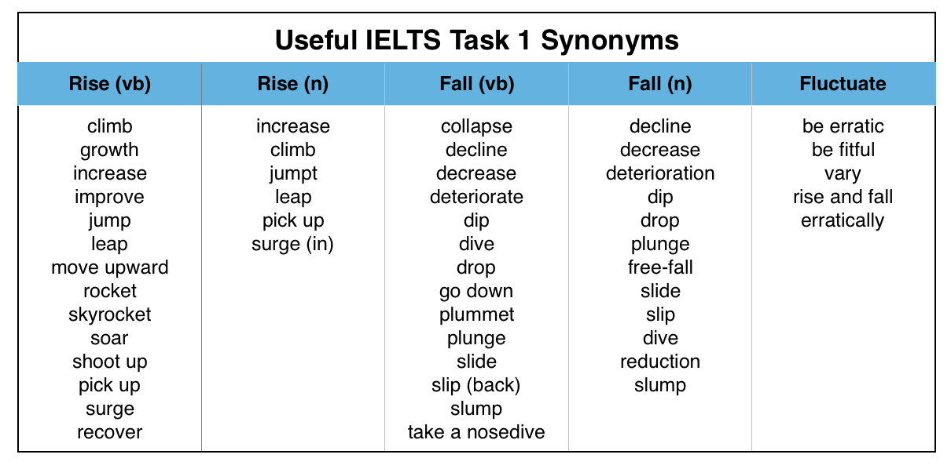

Vocabulary for IELTS Writing Task 2
For the second IELTS Writing Task, the important vocabulary is all about transitions. The most common purpose of Writing Task 2 transitions is to:
- give opinions
- add new information
- compare and contrast ideas
- make conditional statements
- give examples
- describe results
Here is a list of some useful vocabulary words for each of these six transition types:

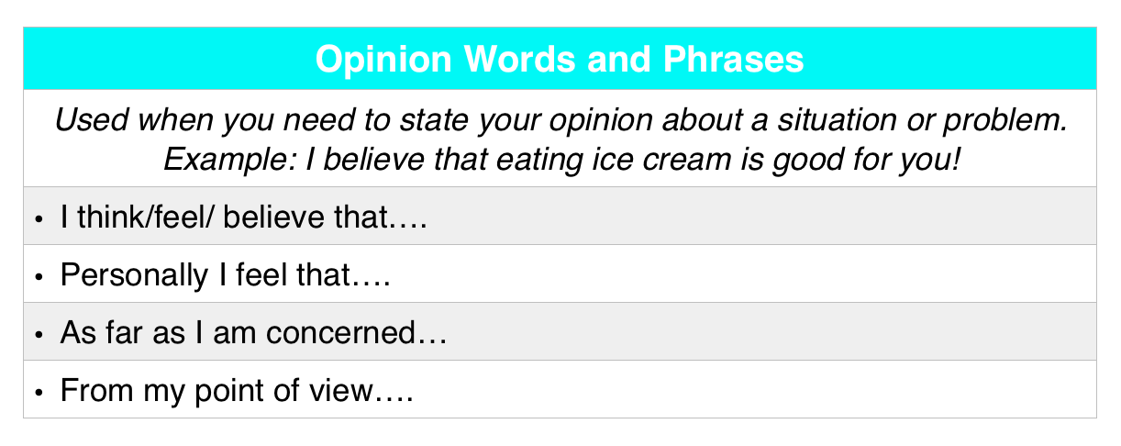

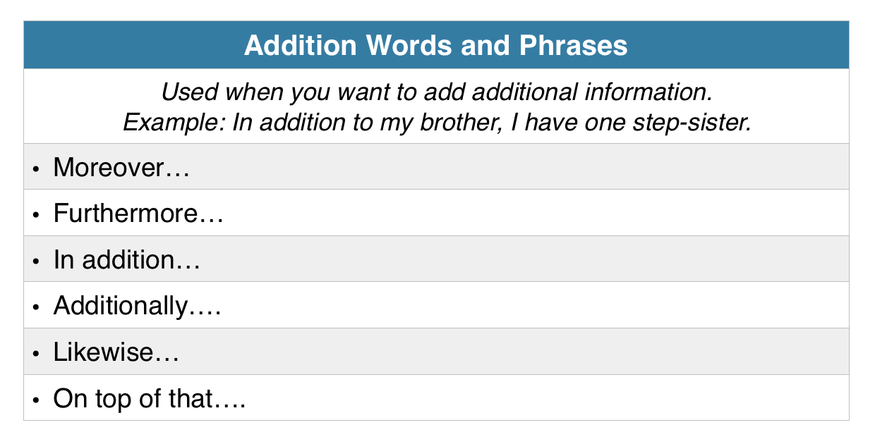

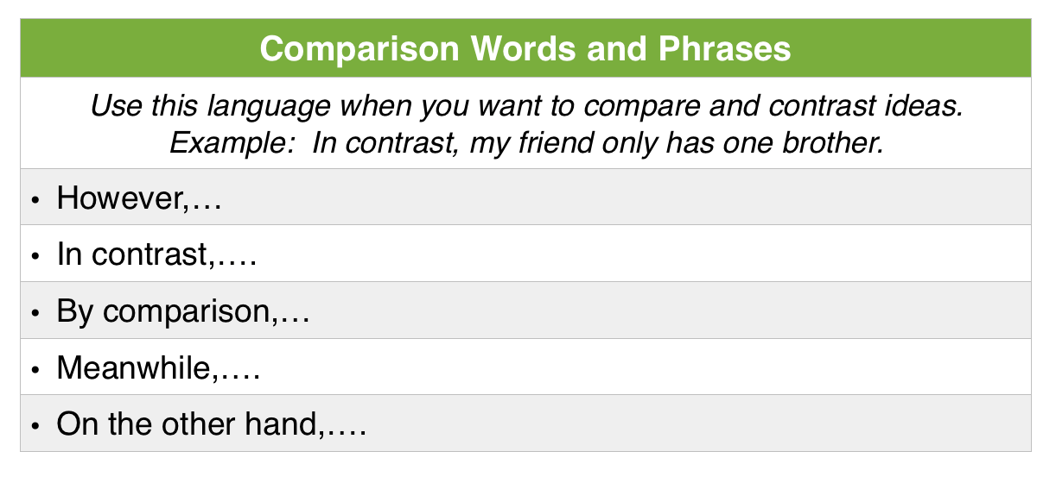

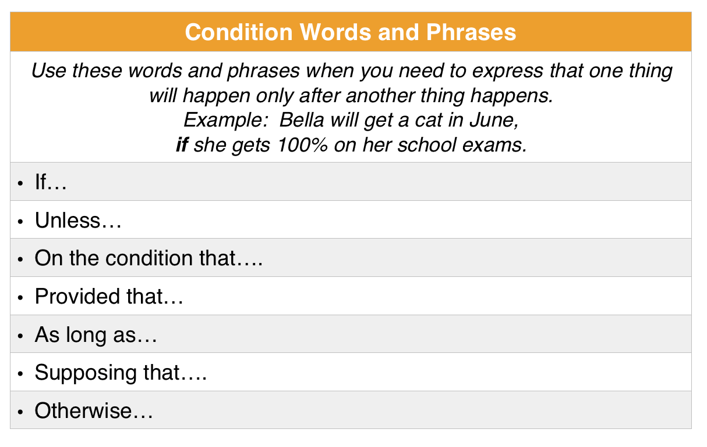

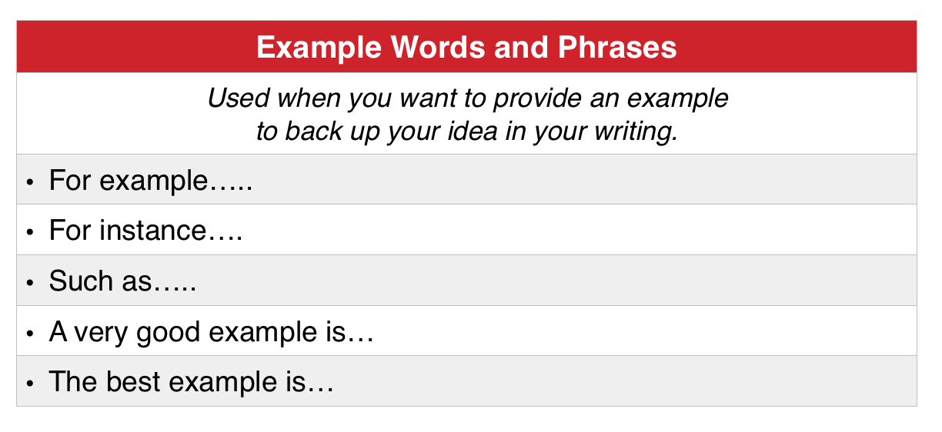

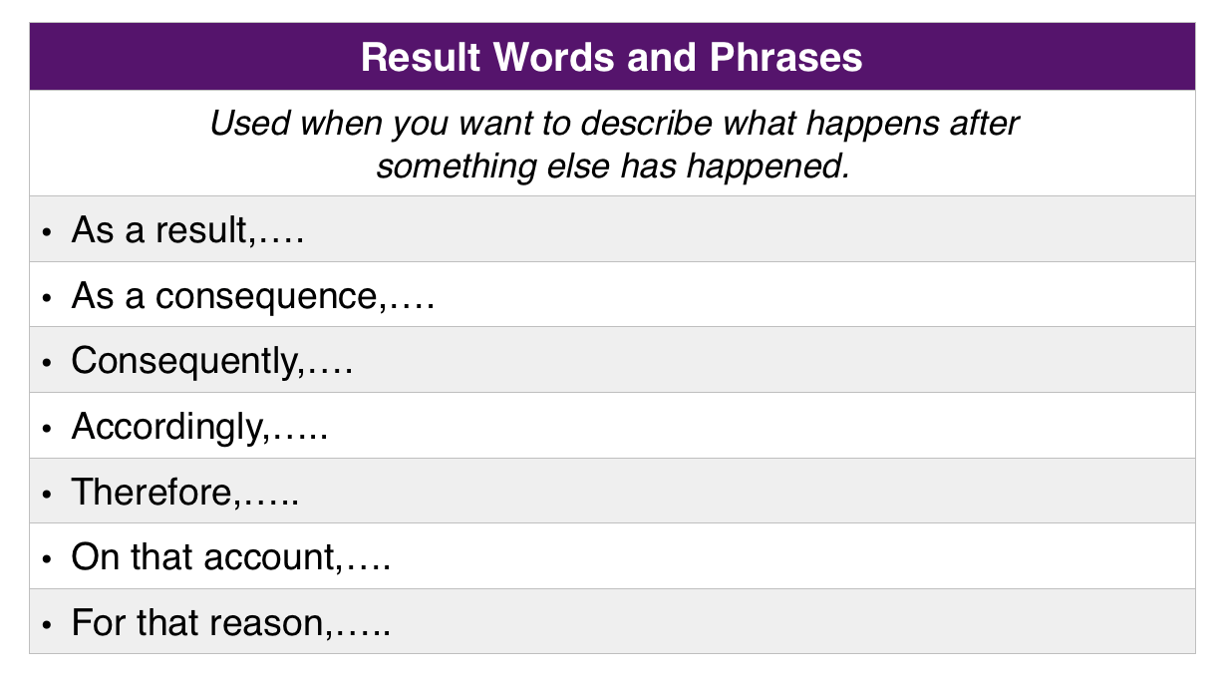

IELTS Speaking

In the IELTS Speaking interview, you’ll deal with two main types of vocabulary. The Speaking Section requires you to hear and say a lot of “function” words that people use when they are asking for information or giving information. It’s also helpful to know a lot of words related to the IELTS Speaking topics.
Below, we’ll look at Speaking vocabulary for exchanging information and making transitions, followed by a few common IELTS Speaking questions, with key vocabulary words highlighted. After that, I’ll give you a list of vocabulary words related to specific common IELTS Speaking topics.

IELTS Speaking Vocabulary: Exchanging Information

Asking for Information

Describe…
“Describe” will appear at the beginning of many IELTS Speaking topic cards. Be ready for requests for information such as “Describe the house you grew up in,” or “Describe your closest friend.”

Would you say that…?
“Would you say that…” is a common phrase in follow-up questions to the initial IELTS topic card enquiry. For the “describe a place you live” question, for instance, the follow-up could be “Would you say it’s a nice place to live?”

Could you explain more…?
This is another follow-up question phrase to listen for. Your IELTS interviewer will use this phrase when he or she wants more detailed information on something you just said. For example, if you tell an IELTS interviewer that your best friend is always very helpful, they might ask “Could you explain more about how your best friend helps you?”

Can you tell me…?
This is an alternate way to start an IELTS question, rather than starting it with a wh-word or “describe.” To give a couple of examples, “” What is your name?” can be rephrased as “Can you tell me your name?” and “Describe your family” could also be asked as “Can you tell me about your family?”

I need to know…
This form of questioning can be easy to miss because it sounds like a statement rather than a question or request. “I need to know” is commonly heard in IELTS Listening. The phrase is often said by a person who has contacted a company or teacher to get information about something.

C onf irming You’ve Gotte n Inf ormation

I got it.
This sentence is used when a listener wants to confirm that they understand the information they’ve just heard. You can use this phrase in IELTS Speaking to tell your interviewer that you understand the instructions they’ve given you.

We’ve been talking about…
Like “I got it,” the phrase “We’ve been talking about…” is used to confirm that information is understood, and to move on to new questions. In a Speaking IELTS interview this phrase introduces new questions on the same topic. For instance, if you’ve been talking about a person who has influenced you, a follow- up question might be “We’ve been talking about influential people in your life.
Would you say you’re more influenced by family members or friends?”

You mentioned…
This phrase is very similar to “We’ve been talking about,” but references a specific fact that has just been discussed, rather than a general topic. A typical example would be “You mentioned that you plan to study engineering. What are your plans for after you graduate?”

You say that…
This is another common way to confirm information and introduce a follow-up question on the IELTS. For example, in an interview about someone’s hometown (possible in both the Speaking section or on a Listening track), you might hear something such as “You say that your hometown is very beautiful. Does it have any popular tourist attractions?”

Sorry,…
In IELTS Speaking, the word “sorry” is frequently used to ask someone to repeat information so it can be properly confirmed. It’s short for “Sorry, I didn’t understand what you just said,” and is said in a questioning tone, as in “Sorry?” If a speaker says “sorry” in a question-tone, the other speaker will know they weren’t understood.

You mean…?
When a speaker wants to confirm what they’ve just been told, they can use the phrase “you mean.” In IELTS Listening, you may hear someone say, “You mean that I need to turn left at the next corner?” to make sure they understand the directions they’ve been given. Or if you want to make sure you understand what an IELTS interviewer is asking you, you might say things like “Do you mean I should tell you about the house I grew up in?” “Do you mean I have time to prepare before I answer this question?” and so on.

As you know…
“As you know” is an interesting phrase on the IELTS because it can be used to confirm facts that are known to both speakers but have not actually been mentioned in the current conversation. One example of this phrase on could be “As you probably know, I will be showing you some topic cards for this IELTS Speaking interview.” This might be said by an IELTS Speaking interviewer.

IELTS Speaking: A Few Common Questions, With Common Vocabulary Keywords
You can be asked a very wide variety of questions in the IELTS Speaking interview. That being said, a few questions are especially likely to come up. Here are a few common IELTS questions that are likely to come up on test day. Important key vocabulary words in these questions are highlighted and explained.
- What do you think the benefits of being able to speak more than one language are?
Benefits: advantages, positive aspects, is beneficial (i.e. The main advantages…/One of the most positive aspects…/Being able to converse in more than one language is extremely beneficial.)

- Can you give me some examples?
Examples: for instance, a good example, the best example (i.e. For
instance…/A good example…. /The best example I can give you…)

- Can you describe a person or incident that made an impression on you?
Made an impression on me: influenced me, had an enormous impact on me, had a lasting effect on me, changed the way I looked at things. (i.e. Watching the twin towers collapse on 9/11 had a lasting effect on me/ changed the way I looked at things/had an enormous impact on me.)

- What type of activities do you like to do in your free time?
Activities: hobby, leisure pursuit, pastime (i.e. My favorite hobby/leisure pursuit, pastime is riding my bicycle.)

- Can you describe something that you own that is very important to you?
Important: significant, indispensable, valuable (i.e. The most important
/significant /indispensable /valuable item I possess is a silver bracelet from my late Aunt Sue.)

The IELTS Speaking “Long Turn”: Transition Phrases
In Part 2 of IELTS Speaking, also known as the Speaking Test’s “long turn,” you will need to give a 2–3-minute speech about a selected IELTS Speaking topic. You’ll be speaking on your own without feedback forma conversation partner. Because no one can ask you for clarification, you’ll need to clearly “mark” the ideas in our speech. How do you do this? With spoken transition words and phrases?

There are several different reasons to use IELTS Speaking transitions. Below is a list of the most common purposes with IELTS Speaking transitions, along with example words and phrases for each type of transition.

- GIVING EXAMPLES: for example, for instance, to give an example, such as, to name a few

- ADDING IDEAS OR DETAILS: in addition, furthermore, moreover, not only/but also, next

- CAUSE AND EFFECT: so, thus, because of, as a result, which caused, this caused

- CLARIFYING: by this I mean, in other words, which is to say, or to put it another way, I mean (x) and not (y)

- COMPARING: for example, for instance, to give an example, such as, to name a few

- CONTRASTING: unlike, as opposed to, on the other hand, even though, although, having said that

- RESTATING/SUMMARIZING: as I mentioned, like I said, in short, all in all, to sum up

- EMPHASIS: even more, above all, in fact, truly, indeed

- MAKING EXCEPTIONS: however, sometimes, still, except for, unless

Transitions in IELTS Speaking Parts 1 and 3
In the conversational parts of the IELTS, transitions are still important. Here, transitions most often take the form of verbal pauses. Verbal pauses are natural ways to slow down a conversation so that speakers can collect their thoughts and decide what they’ll say next.
These pauses ultimately mark the times when new ideas and new interactions happen in English conversation. Real, live conversations can be messy and disorganized, so it’s good to use transitions that help conversation flow smoothly and naturally. Below are a few verbal pauses that can serve you well in the first and final parts of the IELTS Speaking test.

Transitions in IELTS Speaking: Verbal Pauses

- Um…/Well…/Hmm… (in hesitation)
- That’s a tough/interesting/good question.
- Hmm… That’s difficult.
- Wow, I really don’t know.
- Offhand, I’d say…
- Let’s see…
- Good question!
- Well, I suppose…
Introductory transitions are also important in IELTS speaking. They can be used to introduce new ideas, or to present a series or sequence of ideas. As an example, the IELTS Speaking examiner might say “First, let’s consider…” and the candidate might respond, “The first thing that comes to mind…” Later the candidate could add to this this

by saying “Another thing…” Here’s a small list of phrases that carry out this same task
and also serve to introduce topics:

IELTS Speaking Transitions: Introductory Phrases

- First, Second, etc…
- First of all…
- For one…
- How about…? (to offer an example or introduce a topic)
- For a start…
- So, what about…?

Concluding Phrases in IELTS Speaking Conversations
After making a statement, a candidate may ask a question such as, “Understand what I mean?” In most cases, this is not meant to be a real question. It’s something speakers naturally do to keep a conversation moving forward after they’ve concluded one of their statements. Here are some useful conclusion questions for IELTS Speaking.
- …You know what I mean?
- …, you know?
- Does that make sense?
- …, right?

IELTS Speaking: Vocabulary for Common Speaking Topics

Free Time

hobby
a specific activity someone does in their spare time

Pastime
an activity done for enjoyment

collect
a hobby (see “hobby” above) in which someone purchases and keeps a certain
kind of thing (ex: collecting seashells, collecting comic books

outing
a planned activity, done outside of the home for fun, with other people

date
a planned meeting of two people, either romantic or between friends

School

primary
the beginning grade levels of school, for young children; elementary and middle school

secondary
schooling taken immediately before university; high school

discipline
in educational vocabulary, either an academic field of study OR guidance/punishment given to students

marks
scores or grades that students receive on their academic assignments and exams

major
a chosen field of study that a university student earns a degree in

Travel

itinerary
a formally planned trip, usually one arranged through a travel agency, airline, or other travel-services company

vacation package
a group of travel and hospitality services that are purchased together; a vacation package may include hotel fees, airfare, restaurant meals, a trip on a tour bus, etc….

abroad
outside of one’s home country

local
connected to one’s area of origin; local travel is travel in one’s own country or
region, and local people are people who are found in their own country or region

road trip
A long journey by car

Work
Actually, the IELTS Speaking vocabulary words for work are pretty much the same as the IELTS Listening work vocabulary words. For your convenience (so you don’t have to scroll back up to the Listening section of this PDF), I’ve reproduced those words here:

career
“Career” is a more board term than “occupation.” It refers to the category of work someone does and suggests a long-term commitment. To help you understand the difference between occupation and career, I will tell you about my career and the occupations I’ve had in it. I have a career as an educator. My current occupation in this career is a Test Expert position here at QELC. As a part- time occupation, I am also a language tutor. And earlier in my education career, I was occupied (the verb form of occupation) as a middle school teacher, and then as a university professor.

shift work
“Shift work” refers to work that is scheduled with a specific beginning and ending time. A shift at a workplace often lasts 8 hours but can be shorter. Shift work is usually paid for on an hourly basis.

Salary work
Salary work may have an expected schedule, a shift where the worker will normally be at work. But the schedule and hours per day for salary work are not as strictly controlled. A salary worker may have to work much longer hours than usual on a given day or come in on the weekends. Sometimes, however, a salary worker’s situation is the opposite. A salary worker may also work shorter hours and have more freedom to leave the workplace during their normally scheduled shifts. Salary workers aren’t paid by the hour and instead receive a fixed rate of pay per week or month.

unskilled/skilled
Unskilled work is work that requires little or no training, such as fry cook work at a fast-food restaurant, or work cleaning and maintaining buildings. Skilled work does require training. Some workers are so highly skilled that they have doctoral degrees — lawyers and doctors, for example. Other skilled occupations require less training. Skilled work as a plumber, computer programmer, or automotive repairman may only require a four-year degree, a two-year degree, or an even shorter certification.

manual labour
“Manual labour” refers to work that is very physical, requiring a lot of strength and physical activity. Manual labour jobs include unskilled work such as stocking shelves at a grocery store, and skilled work such as welding.

Hometown

downtown
The traditional center of a city, usually containing a business district

rural
describes an area that contains mostly farmland and countryside

urban
describes a city area that is heavily developed and has a large population

outskirts
the areas at the outer edges of a city or town

suburb
a town or city that is very close to a much bigger city; people who live in the suburbs often travel to the big city for work, shopping, events, or gatherings

Friends

get on
to enjoy the company of another person, and to have a good relationship with
them (if two people are good friends, you could say they “get on” well)

night out
an fun evening spent outside of the house and in a public place

meet
to see someone and get to know them for the first time (as in the question “How did you meet?”); to see someone and join them for an activity or event (as in the statement “Let’s meet at the new restaurant.”)

casual
when referring to friends, this means friends that don’t know each other very well (ex: “I don’t even know her family name; we’re very casual friends.”)

close
when referring to friends, this means friends who know each other very well, and perhaps love each other (ex: “He is like a brother to me; we’re very close friends.”)

Weather

chilly
when referring to weather, this means cold in a way that is uncomfortable

muggy
very hot and humid

balmy
not too hot and not too cold, a comfortable outdoor temperature, usually with some gentle wind

sleet
a mix of snow and rain, falling together from the sky

mist
fog; tiny droplets of water that are in the air, close to the ground

Climate

arid
a climate that is dry, with little or no rain

tropical
A warm climate with rain and no winter, found in the regions of the earth near the equator

temperate
a climate with mild temperatures; the summers are not too hot, and the winters are not too cold

Mediterranean
the climate found in nations along the Mediterranean Sea also refers to any climates similar to the Mediterranean, even if they’re found in other parts of the world

seasonal
When referring to climate, this describes the weather that is a typical of a specific
season (ex: “South Pacific Islands get seasonal rain and storms every summer.”)

Food

chain restaurant
a restaurant that is owned by a large company and has many locations, across a nation or across the world; McDonalds is a famous example of this

cafeteria
a restaurant or other place where customers serve themselves food or are served food that is kept behind a counter

ingredients
the things that are combined to make a certain kind of food or dish; (ex: “The
ingredients of a hamburger are bread, meat, pickles, ketchup, and onions.”)

seasoning
a chopped ground, or shredded ingredient or sauce that is added to food to give it extra flavor; salt, pepper, and mustard are examples of seasoning

recipe
instructions for preparing a certain kind of food; a recipe will include a list of ingredients, as well as an explanation on how the ingredients are mixed and how the food is cooked or otherwise made ready for eating

Music, Movies, Books, and Television

episode
one movie in a series of movies that tell a story; one installation of a television series (TV shows usually have one episode on television each week)

chapter
one specific part of a long book; a chapter will usually have a clearly marked beginning, end and number (ex: “Chapter eight of the novel starts on page 115 and is one of the most exciting parts of the book.”)

album
a set of songs or musical compositions that are sold together on a single CD, vinyl record, or cassette tape (ex: “The singer just released a new album with 13 songs.”)

plot
in a fictional book, movie or TV show, the plot is the series of events in the story

setting
in fiction, the location of the story, or the location of part of the story

Recreation, Exercise, and Sports

aerobics
fast-paced exercise, designed to make the lungs and heart stronger

workout
a time period during the day that is spent exercising (ex: “I run for 30 minutes every morning, because I like to start out my day with a good workout.”)

work out
a two-word verb related to the noun “workout;” this word means to get a lot of
good exercise (ex: “I have strong muscles because I often work out.”)

gym
at a school, this is a large indoor room where students have physical education; also refers to a room or facility where people can use exercise equipment such as treadmills and weights

sports
competitive athletic games: activities that involve killing animal outdoors for fun (hunting and fishing)

Traditions and Celebrations

generation
a group of people who were born in the same time period; their children would be the next generation (ex: “Many generations of my family have followed these customs.”)

custom
a specific activity that has been done by a certain group of people for many generations (ex: “Many different countries have a custom of honoring the dead at a certain time of the year.”)

- holiday an individual day or limited time period on which a culture or nation celebrates something (ex: “The Christmas holiday lasts one day, while the Ramadan holiday lasts for a month.”)

observe
when referring to traditions or celebrations, to observe is to do culturally required activities (ex: “In many parts of the world, people observe birthdays by eating cake and giving gifts.”)

festival
a public cultural event where a large group of people are happy and celebrate

Technology and the Internet

social media
websites or phone apps that allow people to share their thoughts and ideas with friends (famous examples include Twitter, Facebook, WhatsApp, and VK)

device
an electronic item that allows people to get on the Internet, make phone calls, or send messages; this word can also refer to any technological machine

mobile
This word describes technology related to phones or other wireless devices that can connect to the Internet or send calls and text messages to people

innovation
a new and valuable idea or invention; this word can also refer to technological changes in general

revolutionize
When referring to technology, this means to make a big, important change the way we use technology

Household

flat/apartment
a home that is part of a larger building; the larger building may also contain other homes or places of business

detached home
a single building that serves as a single home

neighborhood
the immediate area surrounding someone’s home; a neighborhood is generally defined as anything that is within short walking distance of someone’s home

location
this word as a very specific meaning on the IELTS, when “location” is used to
Describe a home, it refers to the kind of neighborhood and city that the home is in

roommates/flatmates
people who are not related to each other, but live together in a home and share
housing costs such as rent, electricity bills, etc…

News and Current Events

headline
The title of a news story that is shown the most clearly in a news publication; in a newspaper, the headline is at the top of the front page, in a magazine, the headline is featured on the front cover, and on a news website, the headline is the biggest article title on the main page of the site

disaster
an event where lots of property is damaged or lots of people are hurt, all by accident; hurricanes or oil spills are disasters that you might commonly see in the news

live
live news is news that you hear or watch at the same time as it is happening; often reporters will film a disaster or record a politician’s speech live so that people can see the disaster or listen to the speech in “real time”

conflict
in the news a “conflict” usually refers to a war or military battle

print vs. broadcast vs. Internet
“print” refers to news that’s printed on paper (magazines and newspapers), “broadcast” refers to television and radio news, and “Internet news” is (of course) news that’s on the Internet

Shopping

sale
an event where a store sells items at less than their usual price; in a more general sense, this word refers to the act of selling something to someone

discount
the act of selling a specific thing or offering a specific thing at a lower price than usual

bargain
a good price; the act of convincing someone to sell something at a lower price

haggle
to negotiate with a seller in an effort to buy something at a different, lower price than the advertised price

spree
an event in which a person does a lot of shopping and buys a lot of things

